Milestone report
MILESTONE: Pre-production
TEAM NAME: Noflex
GAME NAME: Q
NAME: Minjae Kyung
JOBS: Product Manager
DEGREE PROGRAM: RTIS
GAME DESCRIPTION: Our game is a side view platformer rogue-like game. Player is an eminent scientist who participated in the space project.
LINKS: https://github.com/Rudy-Castan-DigiPen-Teaching/game-project-noflex

Work Done :

Enemy AI(~60 hour)
  - My main focus of pre-production was Enemy AI. I almost burn-in in last week
  - When an enemy does not find a player, he just goes back and forth on the block.
  - When an enemy finds a player, it trying to chase a player
  - When an enemy finds a cliff while chasing a player, the enemy checks if it can pass by his jump capacity. if can, it he jumps, or he doesn’t
  - My main problem was checking jump ability. In this version, There is a jump trigger in the map and it stores the requirement value of jumping on a cliff. And Enemy checks requirements and jump ability. If he has enough ability, It jumps the amount of requirements.
  - But this needs a lot of effort and is not flexible. So I will try to find another algorithm that can get more jump more flexible
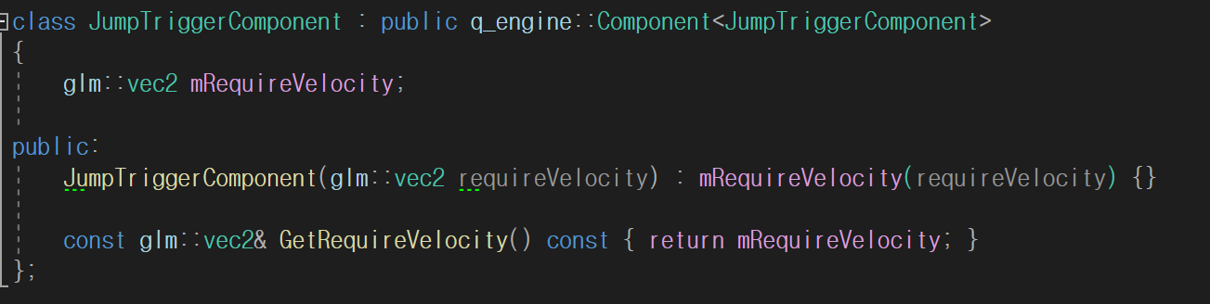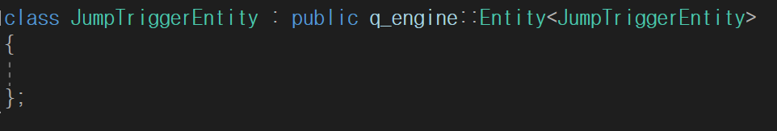
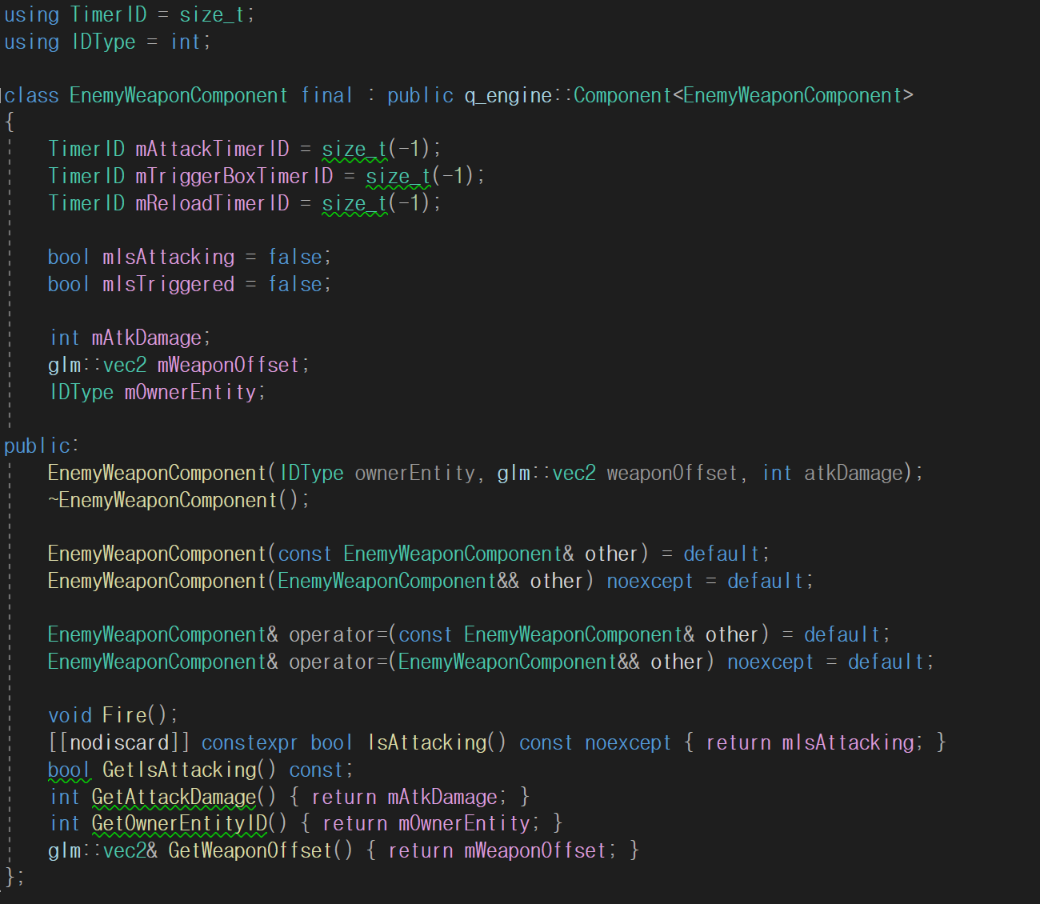
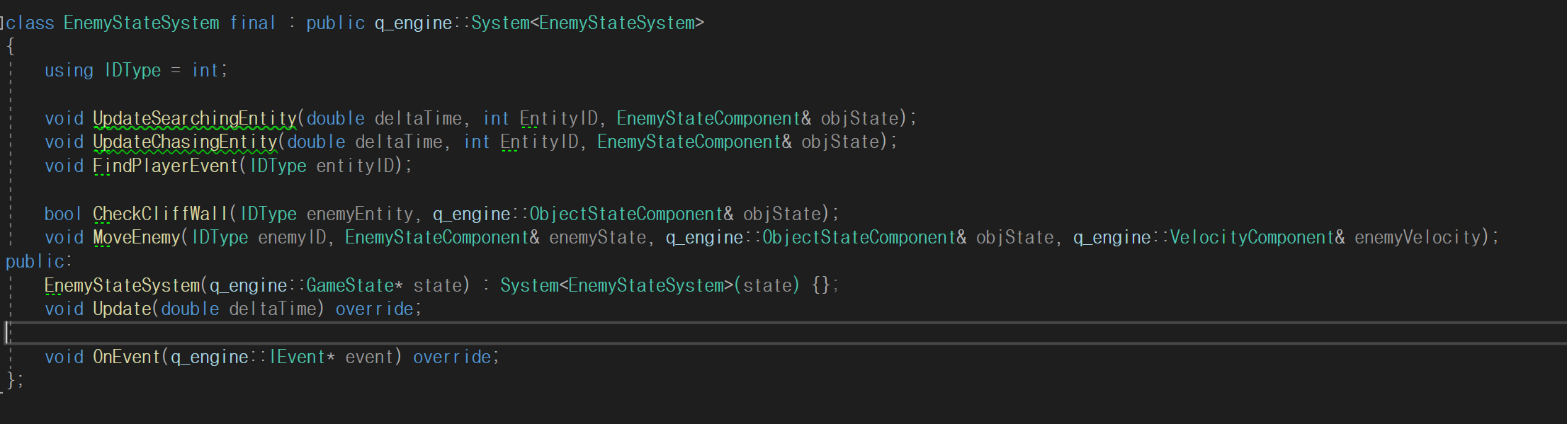
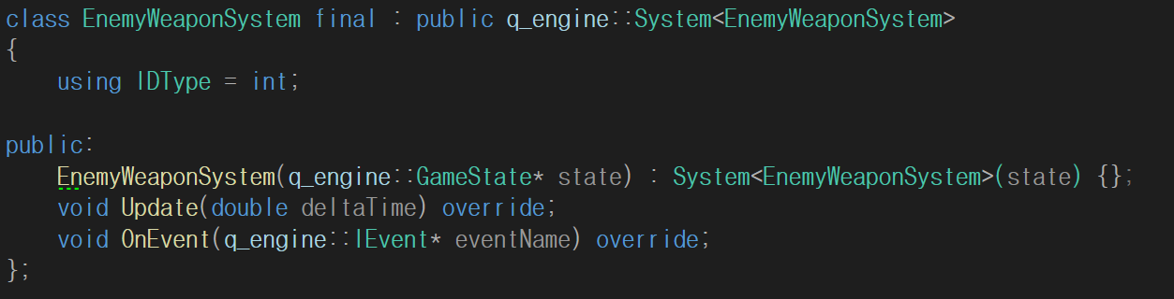

Entity Component Transfer between Levels(~20 hour)
  - I think it will be an easy one but it is not.
  - We can transfer Entities and Components. But the main problem was we don’t want to transfer All the entities and components but player and player items.
  - It is not that hard to move entities but what makes it really hard is we don’t know what type of components an entity has. So we added variadic arguments to entities that need components when transfer.
  - And we use weird traits to unfold functions.
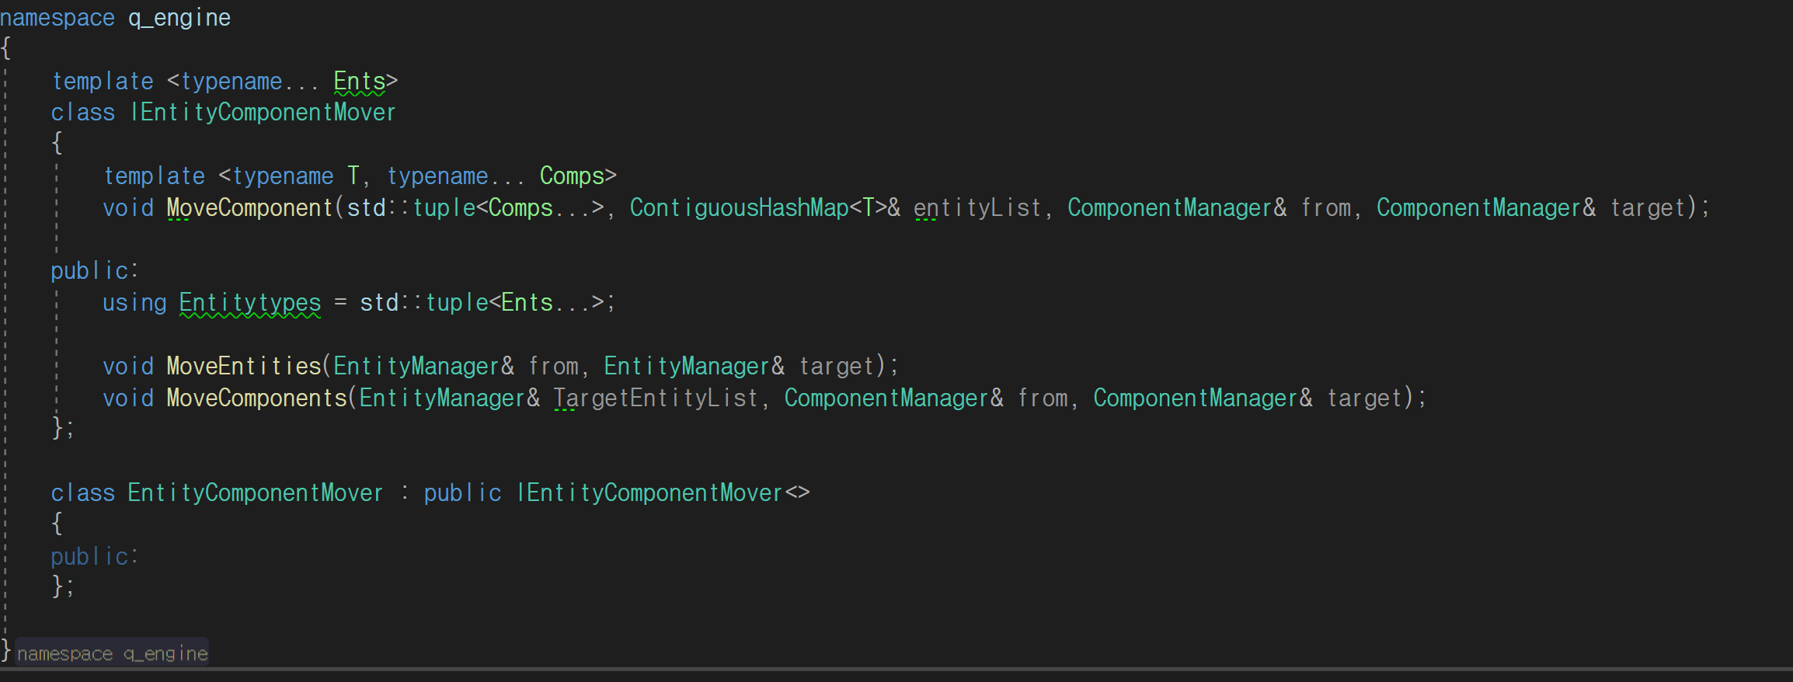

Bug Fixing and adjust some other people’s codes(~20 hour)
  - Due to the fact that I'm an engine programmer, I needed to fix the engine's bugs and adjust other people’s codes because of the change of engine.
  - It spends more time than I expected

Notes :
We have a lot of things to do but I think we are done well in the pre-production milestone.

